Translating fashion style into data: End-to-End implementation and Use cases to leverage Gen AI and Machine learning to define clothing style through embedding models.

Juan Saavedra, Sahitya Chaudhary, Carlotta Orsenigo

Polimi GSOM

{juan.saavedra, sahitya.chaudhary, orsenigo}@gsom.polimi.it

Contents

Abstract 3

1. Introduction 4

2. Literature review 5

3. Methodology 6

3.1. Database and Schemas 6

3.2. Data Collection 7

3.3. Exploratory Data Analysis and Feature Homogenization 8

3.4. Feature Engineering and Embedding Models 9

3.5. Recommendation System Development 9

3.6. Classification and Feature Selection 10

3.7. Semantic Similarity Analysis 11

3.8. Evaluation and Analysis 11

4. Results 11

4.1. Recommendation systems 11

4.2. Similarity Analysis 12

5. Discussion 19

6. Limitations 19

7. Conclusions 20

8.References 20

9. Appendix 21

## Abstract

*In the ever-evolving fashion industry, the ability to analyze and translate clothing styles into structured data has become pivotal for both luxury and retail brands. This paper presents an end-to-end AI-powered framework that leverages generative AI (Gen AI) and machine learning to transform unstructured fashion data into actionable insights. By scraping data from major fashion brands, we deploy large language models (LLMs) to generate product descriptions and structure data from both text and images. This structured data is then stored in a SQL database and utilized to develop two key use cases: (1) a recommendation system that suggests comparable items across luxury and retail brands, and (2) a semantic similarity analysis to identify patterns and potential similarities between luxury and retail products.*

*The paper also explores the application of embedding models and AI techniques, such as cosine similarity and hierarchical clustering, to define and compare clothing styles. Using machine learning algorithms, we further classify brands, determine key differentiating features, and uncover stylistic trends. This research offers a comprehensive approach to leveraging AI in fashion, providing insights into how unstructured data can be systematically transformed to enhance product discovery and innovation in the industry.*

## 1. Introduction

In today’s fast-paced fashion industry, brands are under constant pressure to innovate and adapt to evolving trends. Both luxury and retail brands must continuously analyze market demands and respond with products that resonate with their audience. However, the vast amount of unstructured data available—ranging from images to text descriptions on websites—makes it challenging to systematically extract meaningful insights regarding fashion styles. The unstructured nature of this data complicates efforts to understand patterns in design, style differentiation, and the extent of stylistic similarities or influence between competing brands.

Recent advancements in artificial intelligence (AI), particularly in large language models (LLMs), offer a new pathway to addressing this challenge. LLMs have shown significant potential in transforming unstructured data into structured formats, enabling more nuanced analysis of fashion products. By analyzing product images and text, LLMs can identify and describe key stylistic characteristics such as fit, material, formality, seasonality, colors, texture, transparency, embellishments, shape, length, fabric fluidity, weight, breathability, occasion suitability, sleeve style, neckline, collar style, patterns, pocket presence and placement, and lapel style. This structuring process forms the foundation for deeper analysis and comparison of fashion styles across brands.

In this paper, we present an end-to-end framework that leverages AI and machine learning to transform unstructured fashion data into structured insights. By scraping product data from two luxury brands, and two retail brands, we use LLMs to describe the intricate details of each product and store this structured data in a SQL database. This structured data enables two key use cases: (1) a recommendation model that suggests comparable items across luxury and retail brands based on style characteristics, and (2) a semantic similarity analysis to identify stylistic influences between luxury and retail products.

Through techniques such as cosine similarity, hierarchical clustering, and embedding models, we analyze and quantify the stylistic relationships between fashion items, offering a systematic approach to understanding style differentiation in the fashion industry. This research not only demonstrates the potential of AI to enhance fashion data analysis but also introduces new possibilities for innovation in product recommendation, style classification, and market trend analysis.

## 2. Literature review

In recent times, the fashion industry has undergone significant digital transformation, particularly in luxury and retail fashion. Innovative technologies are being adopted by brands in both industries more frequently to improve consumer experience and optimize operations. For example, high-end businesses have used cutting-edge technology to maintain their unique in-store experiences while providing individualized services that connect online and offline retail (McKinsey, 2024). With the help of these technologies, an environment that is more engaging and meets the expectations of exclusivity of consumers is created. Conversely, big data analytics is being used by retail firms, particularly those that follow fast-fashion business models, to forecast market trends and customer preferences (Shi & Liu, 2023). This change helps businesses to meet their ever-evolving demands for clothing more rapidly. Still, it has also made it harder for them to maintain a brand reputation when their designs resemble those of luxury labels (Shi & Liu, 2023).

The intersection of artificial intelligence (AI) and machine learning (ML) with fashion has resulted in several breakthroughs in how style and clothing designs are interpreted and classified. AI applications, particularly in the field of image recognition, have simplified fashion item classifiers that utilize multi-feature fusion techniques. By employing many attributes including material, color, and pattern to provide thorough style classifications, this technique enables more complex fashion advice (Zhang & He, 2021). Additionally, machine learning algorithms are being used to build new styles by learning from previous design trends and consumer preferences. These models are effective in predicting future trends in clothing styles; thus, fashion designers can learn valuable lessons from them (Keydal & Oymak, 2020).

Today, generative artificial intelligence is an essential tool for the fashion industry's creative processes. Companies can experiment with novel materials, create virtual apparel, and even use style embedding to anticipate consumer preferences with the aid of generative models (Zhang et al., 2023). Artificial intelligence (AI) models are trained to examine vast collections of clothing photos and associated characteristics to identify patterns that characterize various designs. The design process is thus made more inventive and efficient by these models' proposals for fresh styles or arrangements of apparel components that complement a certain brand's image (Hananto & Kim, 2020).

The significance of AI-based project recommendation tools has increased in addition to these industry-specific uses. These technologies create insights from fashion data by applying clustering and classification techniques. This allows brands to suggest products to customers based on their past purchases and tastes (Springer, 2020). Embedding models in fashion helps map consumer preferences to specific design elements, making product recommendations more personalized and enhancing the customer shopping experience (Zhang et al., 2023).

AI’s influence extends well beyond the fashion industry, sparking innovation and enhancing efficiency across a multitude of sectors. AI in manufacturing improves workflows and lowers operating costs by utilizing smart automation and predictive analytics to improve production processes (Delphi, 2023). Remarkable progress is also being made by generative AI in domains including healthcare, cybersecurity, and finance, where it helps with vital functions like fraud prevention, threat identification, and disease diagnosis (JMIR Medical Informatics, 2023). These breakthroughs demonstrate the broad applicability of AI and ML and demonstrate how these technologies have the potential to transform several industries by improving overall business outcomes, productivity, and precision.

In other words, AI and ML are catalyzing a wave of innovation across both fashion and other industries. By adopting these advanced technologies, brands can refine their product lines and create personalized experiences that resonate with consumers. As AI continues to evolve, its influence on shaping the future of fashion and beyond will only grow, offering new opportunities to harness data-driven insights and unleash creative potential across industries.

## 3. Methodology

This study implements an end-to-end AI-powered system for transforming unstructured fashion data into structured insights. Below, we outline the step-by-step process used in the pipeline (Figure 1).

Figure 1: Process pipeline

### **3.1. Database and Schemas**

The structured data was stored in a PostgreSQL database hosted in Docker containers. In addition, Chroma DB was used to store large volumes of vector embeddings generated from product descriptions and images (figure 2). The use of Docker allowed for easy scalability and portability of the system, while Chroma DB facilitated efficient storage and retrieval of high-dimensional embeddings for subsequent machine learning tasks.

Figure 2: Database schema and relations

### **3.2. Data Collection**

The first step involved scraping product data from four key fashion websites. These brands were selected to represent both luxury and retail segments, allowing for a comparative analysis of fashion products. Using custom web scraping tools, we extracted product information such as images, text descriptions, and metadata (Figure 3).

Figure 3: Scrapping process

#### **3.2.1 Data Structuring Using Large Language Models (LLMs)**

Once the raw data was collected, we applied large language models (LLMs) to structure the unstructured data. The LLM was tasked with generating detailed product descriptions and classifying the fashion items based on the following characteristics:

* **Fit** (e.g., tight, loose)
* **Material** (e.g., cotton, silk)
* **Formality** (e.g., casual, formal)
* **Season** (e.g., summer, winter)
* **Colors** (e.g., monochrome, multicolor)
* **Texture** (e.g., smooth, coarse)
* **Transparency** (e.g., sheer, opaque)
* **Details and Embellishments** (e.g., embroidery, sequins)
* **Shape** (e.g., A-line, bodycon)
* **Length** (e.g., mini, midi, maxi)
* **Fluidity of Fabric** (e.g., flowing, stiff)
* **Fabric Weight** (e.g., lightweight, heavy)
* **Breathability** (e.g., breathable, non-breathable)
* **Occasion Suitability** (e.g., casual, business, evening)
* **Sleeve Style** (e.g., long, short, sleeveless)
* **Neckline** (e.g., round, V-neck)
* **Collar Style** (e.g., lapel, mandarin)
* **Patterns and Pattern Placement** (e.g., floral, striped)
* **Pocket Presence, Placement, and Size**
* **Lapel Style**

Each product was analyzed and described using these features, and the structured data was stored in a PostgreSQL database as shown in figure 4. The structured data served as the foundation for subsequent analyses.

Figure 4: Data structuring process

### **3.3. Exploratory Data Analysis and Feature Homogenization**

Exploratory Data Analysis and feature homogenization were critical steps in transforming disorganized fashion data into a structured and usable format. These processes enabled a deeper understanding of the data patterns and ensured consistency across data collected from various sources, which is essential for accurate analysis and modeling.

The EDA process started with an examination of the descriptive and categorical attributes of products from both luxury and retail fashion brands. This involved a comprehensive analysis of elements such as material types, embellishments, patterns, and color schemes, etc. By exploring these features, we identified notable variations in the description lengths and levels of detail provided by different brand tiers.

One of the main challenges encountered was the inconsistent labeling of products. The Large Language Model (LLM) generated highly detailed descriptions for luxury brand items; however, in contrast, it produced less detailed descriptions for retail brand items. To fix this, labels were mapped manually to new labels. These new labels standardize them and grouped similar features together as shown in Appendix, Transformations section.

The homogenized features facilitated more accurate comparisons and analyses across different brands, thereby enhancing the performance of semantic similarity models and recommendation systems that depend on consistent data inputs.

### **3.4. Feature Engineering and Embedding Models**

To convert the structured data into a form suitable for machine learning, we encoded the product features as embeddings. Each feature (e.g., fit, material, color) was transformed into a numerical vector representation. These embeddings were used to capture the semantic meaning of each product and allow for advanced analysis of similarities and differences between luxury and retail items.

We used the following steps to process the data:

* **Normalization**: All features were normalized to ensure uniformity across the dataset.
* **Embedding Models**: Pre-trained embedding models were applied to encode each product’s characteristics into a high-dimensional vector space.
* **Cosine Similarity**: We used cosine similarity to calculate the distance between product vectors, enabling the identification of stylistically comparable items.

Figure 5: algorithm to encode data using Embeddings and centroids.

### **3.5. Recommendation System Development**

Using the structured data and embeddings, we developed a recommendation system featuring three main use cases:

1. **Luxury to Retail Recommendations**: The system finds stylistically comparable items across luxury and retail brands. For example, it identifies retail products that are similar to high-end luxury items.

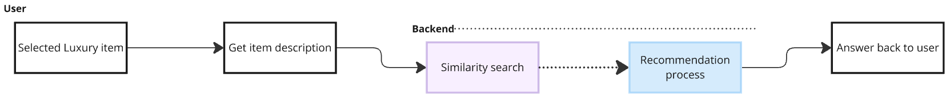

Figure 6: Recommendation process from Luxury item selection

1. **Text-to-Product Recommendations**: Based on a user-provided text description (e.g., "flowing summer dress"), the system suggests products that match the described features.

Figure 7: Recommendation process from user input

1. **Image-to-Product Recommendations**: Using a reference image, the system recommends fashion items that share similar characteristics to the provided image.

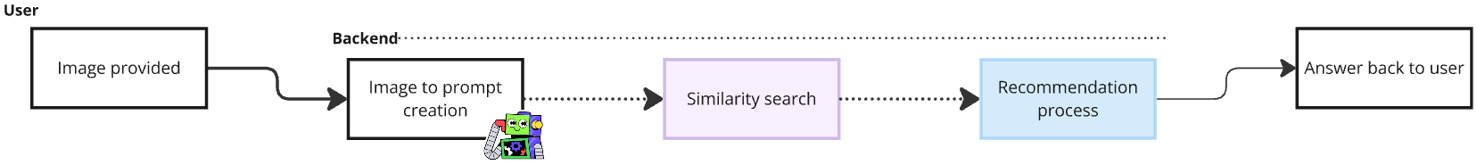

Figure 8: Recommendation process from user image

Figure 9: Similarity search Recommendation Sub process

### **3.6. Classification and Feature Selection**

To differentiate between luxury and retail brands, a **RandomForestClassifier** model was trained, and a **recursive feature elimination (RFE)** process was apply to identify the most relevant features contributing to the classification. This step ensured that the classification model focused on the most impactful characteristics, enhancing both accuracy and interpretability.

### **3.7. Semantic Similarity Analysis**

To assess the stylistic similarities and differences between luxury and retail fashion items, we applied the following techniques:

* **Hierarchical Clustering**: We applied hierarchical clustering to group comparable products based on their embedding vectors. This allowed us to visualize clusters of stylistically comparable items across luxury and retail brands.
* **Cluster Heatmap**: A cluster heatmap was generated using linkage scores to further analyze the relationships between items. This heatmap enabled us to identify clusters of luxury items that were stylistically similar to retail products, as well as those that were distinct.

### **3.8. Evaluation and Analysis**

The decisive step involved evaluating the system’s performance in both recommendation and semantic similarity analysis. We assessed the effectiveness of the recommendation model through user feedback and validation metrics, such as precision and recall. For semantic similarity, we examined the clusters generated to understand how retail brands may be influenced by luxury fashion or, conversely, how they differ in design and explore the top 3 least and most similar items.

## 4. Results

The results of this study highlight the strengths and limitations of using AI-driven models to translate unstructured fashion data into actionable insights for both recommendation systems and similarity analysis. Below, we present the outcomes for each of the two key use cases: (1) the recommendation system and (2) the creation of tabular data for brand classification and similarity analysis.

### **4.1. Recommendation systems**

The recommendation system, designed to suggest fashion items from retail brands that align with those in luxury brands, delivered satisfactory results. The model leveraged both text and image-based inputs to generate recommendations, which were assessed across use cases:

#### **4.1.1 Recommendation of retail items from luxury item selection**

By selecting an item from luxury brands, the system identified retail alternatives that shared a similar style, material, and purpose. These recommendations aligned well with the intended use case of finding comparable items in retail to luxury products, which can aid users in discovering more affordable alternatives.

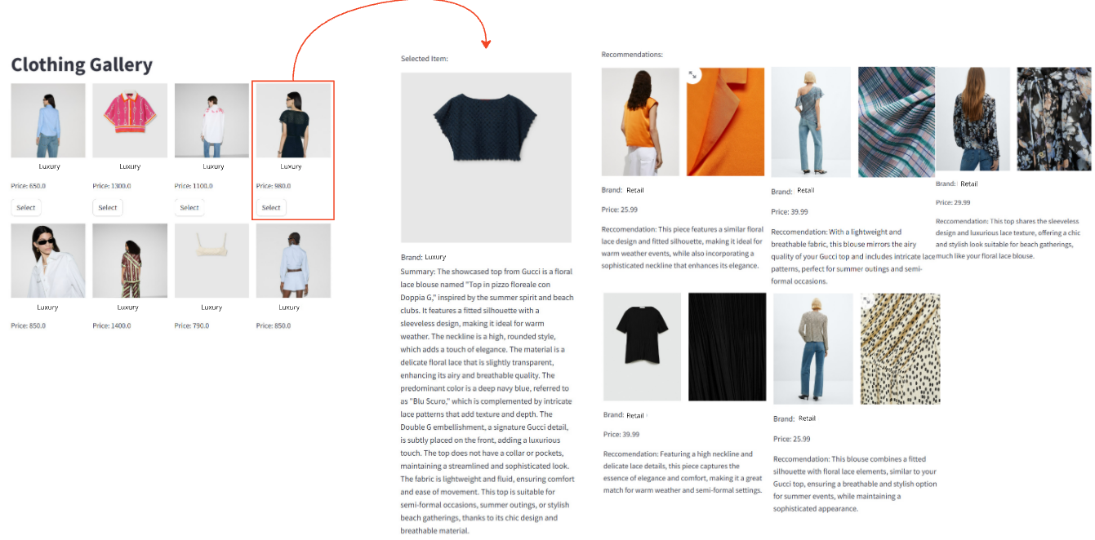

Figure 10: Recommendation of retail items from luxury item selection

#### **4.1.2 Recommendation of retail items from luxury item selection**

The system was able to accurately match user-generated text prompts (e.g., "flowing summer dress") with relevant fashion items that met the described characteristics. The recommendations were considered intuitive and useful for identifying items based on user preferences. A screenshot of a website

Figure 11: Recommendation of retail items from luxury item selection

### **4.2. Similarity Analysis**

In contrast, the second use case—creating tabular data using embedding models and centroids for similarity analysis to identify equivalent items between luxury and retail brands—showed mixed results. While the approach was successful for certain tasks, its limitations became evident during deeper analysis:

#### **4.2.1 Classification between Brand, and Luxury and Retail products**

The tabular data generated by embedding models and centroids performed well when applied to machine learning models, such as the RandomForestClassifier. The model was able to accurately classify fashion items as either luxury or retail based on structured characteristics, achieving good accuracy levels. Similarly, the classifier was effective in distinguishing between brands, identifying stylistic features that separate different luxury and retail fashion houses.

**Luxury and Retail Classification**

|  |  |  |  |
| --- | --- | --- | --- |
|  | **Precision** | **Recall** | **F1-score** |
| 0 | 0.91 | 0.95 | 0.93 |
| 1 | 0.88 | 0.78 | 0.82 |
|  |  |  |  |
| Accuracy |  |  | 0.90 |
| Macro avg | 0.89 | 0.87 | 0.88 |
| Weighted avg | 0.90 | 0.90 | 0.90 |

To enhance the performance of the classification model, **recursive feature elimination (RFE)** was applied. The selected features were the same ones used during the cosine similarity and semantic analysis, including Neckline, Patterns, Formality, and Materials.

|  |  |  |  |  |
| --- | --- | --- | --- | --- |
| **Feature** | **Importance** |  | **Feature** | **Importance** |
| Neckline | 0.1711 |  | Neckline | 0.3259 |
| Patterns | 0.1253 |  | Patterns | 0.2425 |
| Materials | 0.1004 |  | Formality | 0.2235 |
| Formality | 0.097 |  | Materials | 0.205 |
| Occasion_suitability | 0.0689 |  |  |  |
| Colors | 0.0671 |  |  |  |
| Type | 0.0612 |  |  |  |
| Details_and_embellishments | 0.0589 |  |  |  |
| Sleeve_style | 0.0428 |  |  |  |
| Fit | 0.039 |  |  |  |
| Shape | 0.0362 |  |  |  |
| Collar_style | 0.0314 |  |  |  |
| Fluidity_of_fabric | 0.0255 |  |  |  |
| Pocket_presence | 0.0196 |  |  |  |
| transparency | 0.0151 |  |  |  |
| Fabric weight | 0.0086 |  |  |  |
| Breathability | 0.0077 |  |  |  |
| lenght | 0.007 |  |  |  |
| texture | 0.002 |  |  |  |

Improving each metric:

|  |  |  |  |
| --- | --- | --- | --- |
|  | **Precision** | **Recall** | **F1-score** |
| 0 | 0.95 | 0.95 | 0.95 |
| 1 | 0.89 | 0.89 | 0.89 |
|  |  |  |  |
| Accuracy |  |  | 0.94 |
| Macro avg | 0.92 | 0.92 | 0.92 |
| Weighted avg | 0.94 | 0.94 | 0.94 |

**Brand Classification**

|  |  |  |  |
| --- | --- | --- | --- |
|  | **Precision** | **Recall** | **F1-score** |
| 0 | 0.60 | 0.60 | 0.60 |
| 1 | 1 | 0.50 | 0.67 |
| 2 | 0.75 | 0.50 | 0.60 |
| 3 | 0.70 | 0.88 | 0.78 |
|  |  |  |  |
| Accuracy |  |  | 0.71 |
| Macro avg | 0.76 | 0.62 | 0.66 |
| Weighted avg | 0.73 | 0.71 | 0.70 |

As in the previous, RFEwas applied. The selected features were the same ones used during the cosine similarity and semantic analysis, including Neckline, Patterns, Formality, Materials, Colors, and sleeve style.

|  |  |  |  |  |
| --- | --- | --- | --- | --- |
| **Feature** | **Importance** |  | **Feature** | **Importance** |
| Materials | 0.1711 |  | Materials | 0.2956 |
| Neckline | 0.1253 |  | Neckline | 0.2461 |
| Colors | 0.1004 |  | Colors | 0.1919 |
| Patterns | 0.097 |  | Patterns | 0.1749 |
| Sleeve_style | 0.0689 |  | Sleeve style | 0.091 |
| Formality | 0.0671 |  |  |  |
| Details_and_embellishments | 0.0612 |  |  |  |
| Occasion_suitability | 0.0589 |  |  |  |
| Fit | 0.0428 |  |  |  |
| Type | 0.039 |  |  |  |
| Shape | 0.0362 |  |  |  |
| Pockets | 0.0314 |  |  |  |
| Collar_style | 0.0255 |  |  |  |
| Pocket_presence | 0.0196 |  |  |  |
| Fabric weight | 0.0151 |  |  |  |
| Breathability | 0.0086 |  |  |  |
| transparency | 0.0077 |  |  |  |
| lenght | 0.007 |  |  |  |
| texture | 0.002 |  |  |  |

Improving the accuracy by penalizing the precision of the brand#1.

|  |  |  |  |
| --- | --- | --- | --- |
|  | **Precision** | **Recall** | **F1-score** |
| 0 | 0.80 | 0.80 | 0.80 |
| 1 | 0.75 | 0.75 | 0.75 |
| 2 | 0.75 | 0.50 | 0.60 |
| 3 | 0.78 | 0.88 | 0.82 |
|  |  |  |  |
| Accuracy |  |  | 0.77 |
| Macro avg | 0.77 | 0.73 | 0.74 |
| Weighted avg | 0.77 | 0.77 | 0.77 |

The application of RFE led to improved model accuracy by eliminating irrelevant or redundant features, allowing the model to focus on the most impactful characteristics. As a result, the classifier was able to accurately categorize products as luxury or retail, achieving higher levels of precision. Similarly, the model successfully differentiated between brands within each category, identifying key stylistic elements unique to specific luxury and retail fashion houses.

**Confusion Matrix**

By using a confusion matrix, is possible to have insight into the performance of the classification model in distinguishing between luxury and retail brands. The model demonstrates a high degree of accuracy in correctly classifying brands within their respective categories. Key observations include:

Figure 12: Confusion

* **Luxury Brand Classification**: brand 1 and brand 2 were correctly classified most of the time, with the model achieving an accuracy of 80% for Brand 1 and significant accuracy for Brand 2 as well. However, there is some overlap, indicating occasional confusion between luxury brands and retail brands.
* **Retail Brand Classification**: brand 3 and brand 4 were also generally well-classified. The model showed strong accuracy for Mango, with very few misclassifications. Brand 3 had some confusion with Brand 4, reflecting the similarity in styles between these two retail brands.

Overall, the confusion matrix reflects that the model performs well in differentiating between luxury and retail categories but has some difficulty distinguishing individual brands within each category. This suggests that while certain features are effective for broad classification (luxury vs. retail), finer distinctions between specific brands may require additional or more nuanced features to improve classification accuracy further

#### **4.2.2 Cosine similarity and semantic analysis**

Despite the effectiveness of the embedding model in generating structured data for classification, its performance in generating actionable data insights was limited. When examining the cosine similarity matrix and the heatmap generated from hierarchical clustering, the results failed to reveal meaningful relationships or patterns between luxury and retail brands. Unlike the recommendation model, which was able to identify stylistic similarities, the embedding-based model did not clearly differentiate between similar or dissimilar items in a way that provided useful insights.

A sample of items were selected from the six clusters in the luxury items to evaluate the cosine similarity.

Figure 13: Dendrogram highlighting the clusters and the selected items to explore

Generating the following heatmap to understand the most and least similar clothing peaces in the retail space:

Figure 14: Heatmap of the selected items to explore

To better explore the most and least similar clothing, we selected the top and least 3 items for each luxury item, allowing us to compare the images and its characteristics.

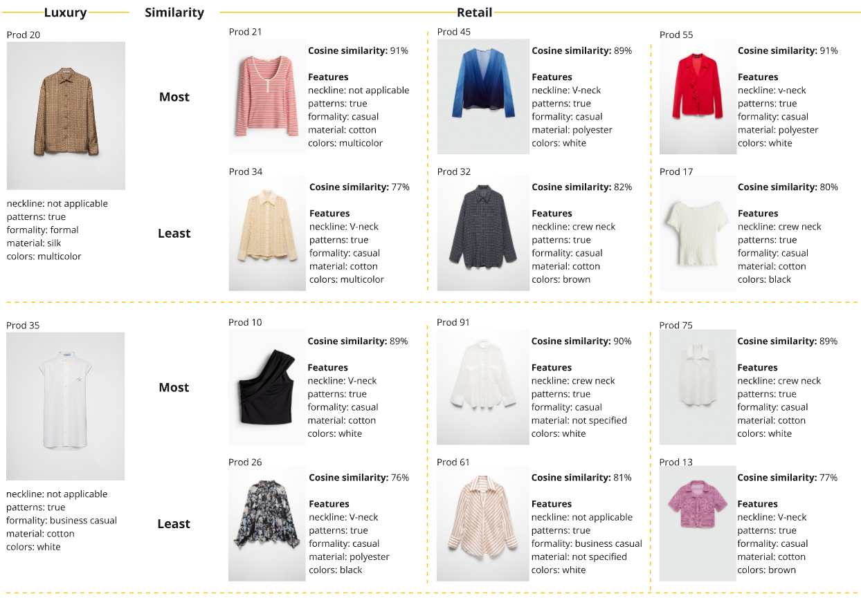

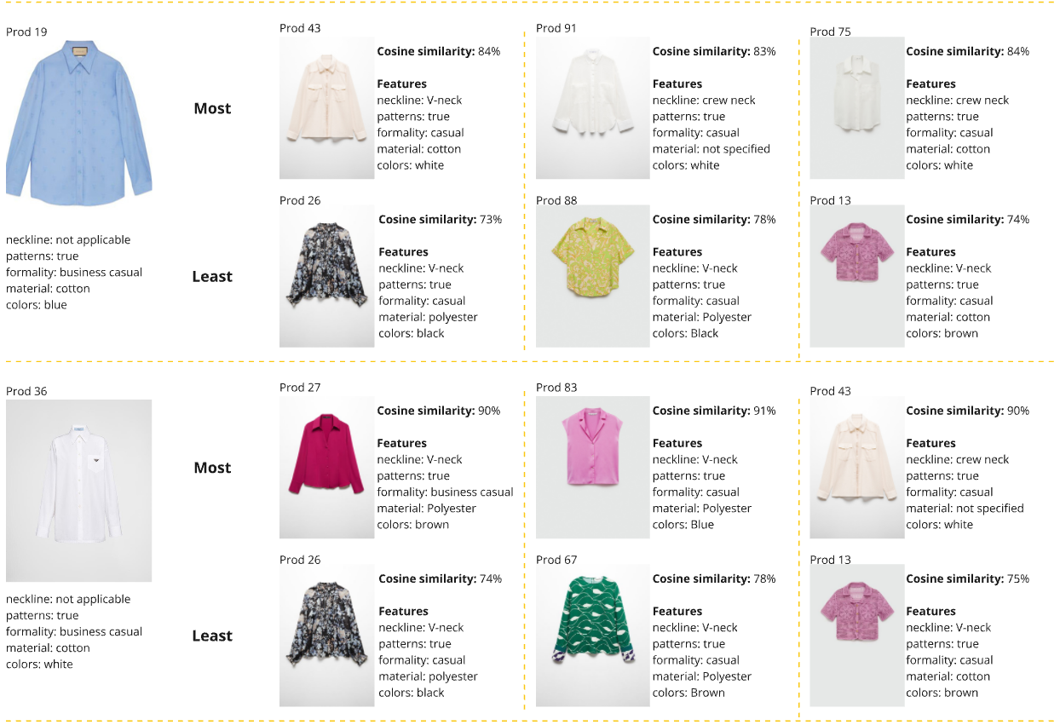

Figure 15: Luxury with the most and least similar retail clothing with details

In particular, the heatmap visualization did not uncover significant clusters or stylistic overlaps between luxury and retail products. While the matrix did highlight differences between brands, it did not lead to the identification of specific items or features that could be considered unique or copied across the luxury-retail divide. This limitation suggests that while the framework is sufficient for classification purposes, it may not be ideal for deeper insight generation or the identification of nuanced similarities and differences between brands.

## 5. Discussion

This study demonstrates that leveraging large language models (LLMs) is an effective approach for transforming unstructured fashion data into structured, labeled data in a relatively fast and automated manner. The LLM effectively facilitated the generation of detailed descriptions for products, enabling the translation of intangible concepts like style into tangible data points that could be used for analysis. This process proved particularly valuable for the creation of recommendation models and brand classification use cases, showcasing the potential of AI in enhancing fashion data analytics.

However, despite the success of using LLMs for data structuring, the quality of the generated data requires further attention. During the process, certain limitations were observed, such as the LLM's occasional inability to accurately identify colors, patterns, or specific clothing categories (e.g., sleeves, collars) when they were not present. These inaccuracies highlight the need for additional steps and quality checks to ensure the accuracy and consistency of the structured data, especially when such data will be used for downstream machine learning tasks.

The proposed framework successfully demonstrates how AI can be employed to translate abstract concepts such as fashion style into data-driven insights, offering a promising approach for future applications. While the recommendation system yielded satisfactory results, the analysis of the structured data for generating deeper insights fell short of expectations. The current embedding models did not fully capture the nuanced relationships between luxury and retail fashion items, indicating that further experimentation with different embedding techniques is necessary to achieve more meaningful results.

The classification model performed well in distinguishing between luxury and retail brands, despite the existing data quality issues. This success can be attributed to the consistency achieved by using the same LLM to describe all the clothing items, which ensured uniformity in data representation across brands. This finding suggests that even when individual data points may have inaccuracies, overall consistency plays a critical role in maintaining classification accuracy.

## 6. Limitations

The main limitations of this study are: the LLM occasionally misidentified certain characteristics (e.g., colors, patterns, garment details), which affected data quality and subsequent analysis. The embedding models struggled to capture nuanced relationships between luxury and retail items, resulting in less insightful semantic similarity analysis. Additionally, data quality issues arose from web scraping inconsistencies, the limited representation of brands, and the lack of human validation. The reliance on pre-trained, non-fashion-specific models and the significant computational resources required also posed challenges, limiting the generalizability, scalability, and depth of insights into abstract fashion concepts.

## 7. Conclusions

In conclusion, this framework represents a promising first step in leveraging AI and machine learning to analyze the fashion industry, the clothing and translating style into data. Further refinement, such as conducting additional analysis on individual characteristics and experimenting with various embedding models, will be necessary to improve data quality and generate more insightful analyses. Despite the current limitations, the study demonstrates the potential of using AI to translate complex, intangible elements of fashion into structured data, paving the way for more advanced applications in fashion analytics and recommendation systems.

## 8.References

* McKinsey. (2024). Preserving the magic of luxury retail experiences. Retrieved from https://www.mckinsey.com/featured-insights/themes/ preserving-the-magic-of-luxury-retail-experiences
* Shi, W., & Liu, C. (2023). How Do Fast-Fashion Copycats Affect the Popularity of Premium Brands? Evidence from Social Media. Semantic Scholar. https://www.semanticscholar.org/paper/How-Do-Fast-Fashion- Copycats-Affect-the-Popularity-Shi-Liu/ bb8e12c1b3306a771542b4a07a9d3938f2c09383
* Zhang, X., & He, Y. (2021). Image Multi-Feature Fusion for Clothing Style Classification. Semantic Scholar. https://www.semanticscholar.org/paper/ Image-Multi-Feature-Fusion-for-Clothing-Style-Zhang-He/ 3b3237c5573457e25a1273c9a3131e023960f039
* Keydal, Y., & Oymak, S. (2020). The Art of Machine Learning as Fashion Stylish for Designing Clothes. Semantic Scholar. https:// www.semanticscholar.org/paper/The-Art-of-Machine-Learning-as-Fashion- Stylish-for-Keydal-Oymak/29dfc265a66edee4f5b5dbf0295fc6e1d10b5760
* Hananto, F., & Kim, S. (2020). A Machine Learning Approach to Analyze Fashion Styles from Large Collections of Online Customer Reviews. Semantic Scholar. https://www.semanticscholar.org/paper/A-Machine- Learning-Approach-to-Analyze-Fashion-from-Hananto-Kim/ 08dd3b13c787d30c02b7ab9ddde12f63f9f41f03
* Springer. (2020). Clustering & Classification in Fashion AI & Recommendation Algorithm. https://link.springer.com/chapter/ 10.1007/978-3-030-49186-4_36
* JMIR Medical Informatics. (2023). Preliminary Evidence of the Use of Generative AI in Health Care Clinical Services: Systematic Narrative Review. <https://www.jmir.org>

## 9. Appendix

**9.1Transformations:**  
**Material**

|  |  |  |
| --- | --- | --- |
| **Original** |  | **Homogenized** |
| cotton |  | cotton |
| cotton gabardine |  | linen |
| crochet-knit (likely cotton or a cotton blend) |  | mixed |
| crépe, lamé |  | not specified |
| flannel |  | polyester |
| fluid fabric |  | silk |
| fluid fabric (exact material not specified) |  | velvet |
| (likely polyester or a blend) |  |  |
| fluid fabric (likely polyester or a polyester blend) |  |  |
| fluid fabric(likely polyester or blend) |  |  |
| fluid fabric, likely polyester or a blend |  |  |
| lace |  |  |
| likely cotton (cannot confirm without full description) |  |  |
| likely polyester (fluid fabric) |  |  |
| linen |  |  |
| mixed cotton |  |  |
| mixed fabric (specific materials not provided) |  |  |
| not specified (cannot be determined from the images and description) |  |  |
| oxford cotton |  |  |
| polyester |  |  |
| poplin |  |  |
| satin |  |  |
| silk |  |  |
| silk, crepe de chine |  |  |
| velvet |  |  |

**Details**

|  |  |  |
| --- | --- | --- |
| **Original** |  | **Homogenized** |
| bandana print, knot detail at the front |  | buttons |
| button-up front, cuffs with buttons |  | Not recognized |
| buttons |  | pattern |
| buttons on cuffs |  | buttons, embroidery |
| buttons on the back |  | embroidery |
| buttons, buttoned cuffs |  |  |
| buttons, cuffs |  |  |
| buttons, embroidery |  |  |
| buttons, front chest pocket |  |  |
| buttons, gg logo pattern |  |  |
| buttons, gg pattern |  |  |
| buttons, gg supreme pattern |  |  |
| buttons, pleats |  |  |
| buttons, pleats, chest pockets |  |  |
| buttons, ribbon |  |  |
| embroidery |  |  |
| embroidery, buttons |  |  |
| embroidery, double g logo |  |  |
| floral print |  |  |
| gg logo pattern |  |  |
| jacquard pattern |  |  |
| none |  |  |
| print |  |  |
| stripes, printed design |  |  |

**Fabric weight**

|  |  |  |
| --- | --- | --- |
| **Original** |  | **Homogenized** |
| fluid |  | Heavy |
| high |  | Light |
| low |  | Medium |
| medium |  |  |
| moderate |  |  |

**Occasion Suitability**

|  |  |  |
| --- | --- | --- |
| **Original** |  | **Homogenized** |
| business casual |  | business casual |
| business casual, casual |  | casual |
| business casual, formal |  | formal |
| casual |  |  |
| casual, business casual |  |  |
| casual, business casual, formal |  |  |
| formal |  |  |
| formal, business casual |  |  |

**Patterns**

|  |  |  |
| --- | --- | --- |
| **Original** |  | **Transformed** |
| floral |  | TRUE |
| geometric |  | FALSE |
| geometric (gg logo pattern) |  |  |
| geometric (gg logo) |  |  |
| geometric, stripes |  |  |
| jacquard |  |  |
| paisley |  |  |
| patchwork |  |  |
| patchwork, heritage |  |  |
| stripes |  |  |
| stripes, equestrian-inspired print |  |  |
| stripes, horsebit print |  |  |

**Pockets**

|  |  |  |
| --- | --- | --- |
| **Original** |  | **Transformed** |
| chest |  | TRUE |
| front sides |  | FALSE |
| left chest |  |  |
| right chest |  |  |

**Shape**

|  |  |  |
| --- | --- | --- |
| **Original** |  | **Homogenized** |
| boxy |  | boxy |
| fitted |  | fitted |
| flared |  | flared |
| relaxed |  | relaxed |
| straight |  | straight |
| straight-cut |  |  |

**9.2 Material distribution by retail and luxury brands:**

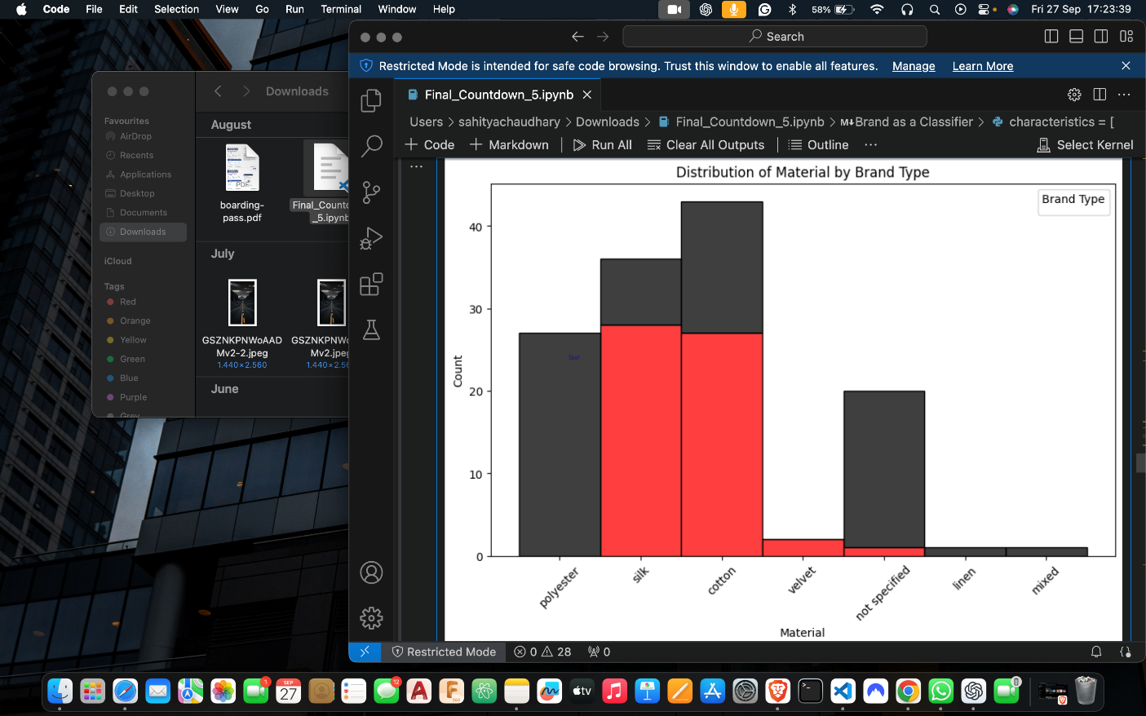

Figure 16: material breakdown by retail and luxury

**Data Analysis**

**Complete heatmap**

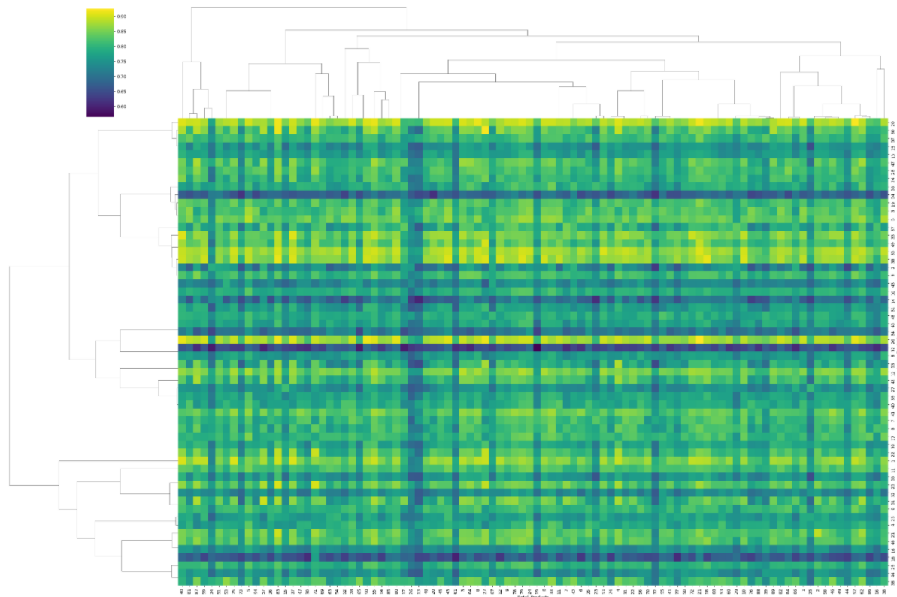

Figure 17: All items heatmap. X axis = Retail, Y axis = luxury